**DAILY ONLINE ACTIVITIES SUMMARY**

|  |  |  |  |  |  |  |  |  |
| --- | --- | --- | --- | --- | --- | --- | --- | --- |
| **Date:** | **09-06-2020** | | | | | **Name:** | **Kanaka BS** | |
| **Sem & Sec** | **6th - A** | | | | | **USN:** | **4AL17CS039** | |
| **Online Test Summary** | | | | | | | | |
| **Subject** | | **CGV-IV**  **CNSC-III** | | | | | | |
| **Max. Marks** | | **30**  **60** | | **Score** | | | **27**  **41** | |
| **Certification Course Summary** | | | | | | | | |
| **Course** | **Complete Python Developer in 2020** | | | | | | | |
| **Certificate Provider** | | | **Udemy** | | **Duration** | | | **30 hours** |
| **Coding Challenges** | | | | | | | | |
| **Problem Statemen:**  **1. C Program to rotate the matrix by K times.**  **2. Python to implement Perfect Sum Problem.**  **3. Java Program to print smallest and biggest possible palindrome word in a given string**  **4. Python Program to count even and odd numbers**  **5. Java Program to remove all white spaces from a string without using replace()** | | | | | | | | |
| **Status: executed** | | | | | | | | |
| **Uploaded the report in Github** | | | | | **yes** | | | |
| **If yes Repository name** | | | | | <https://github.com/kanakabs/Daily-Status/tree/master/09-06-20/online%20coding> | | | |
| **Uploaded the report in slack** | | | | | **Yes** | | | |

CERTIFICATION DETAILS

Progress..

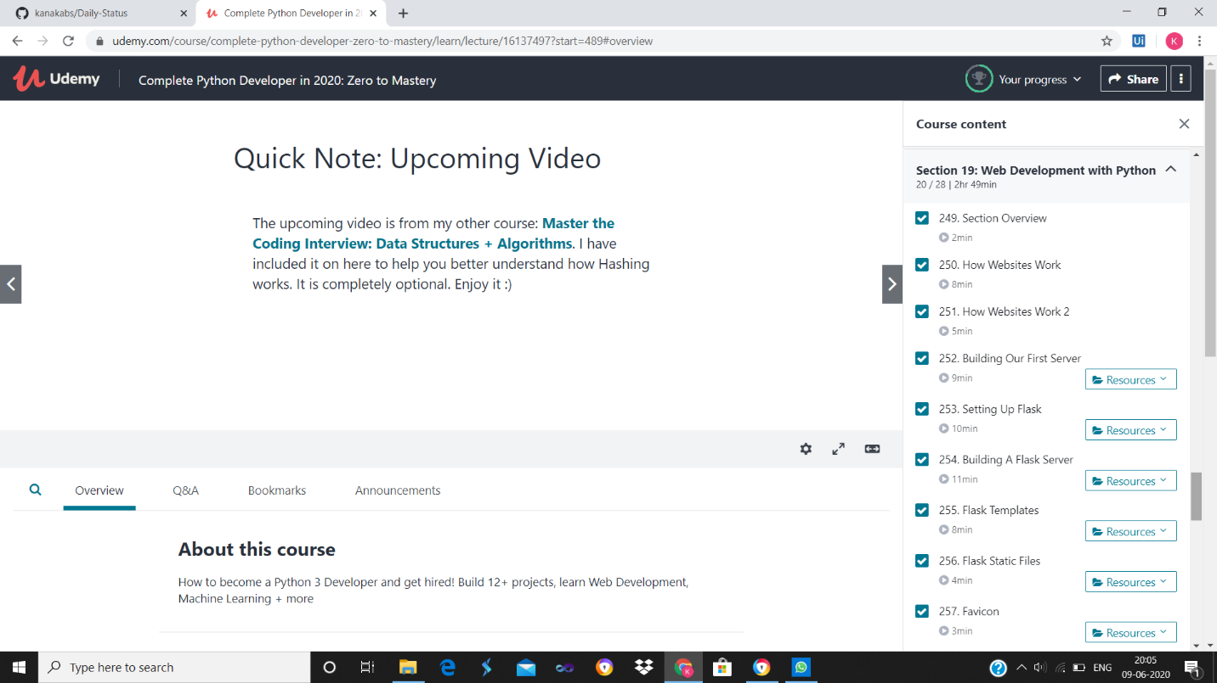

ONLINE TEST DETAILS

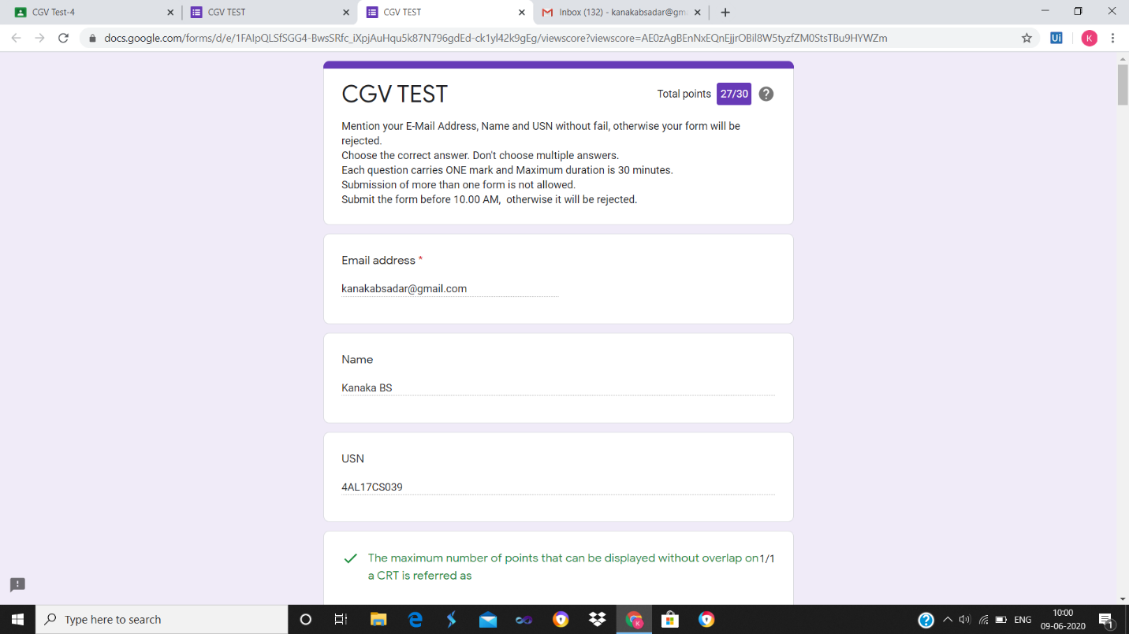

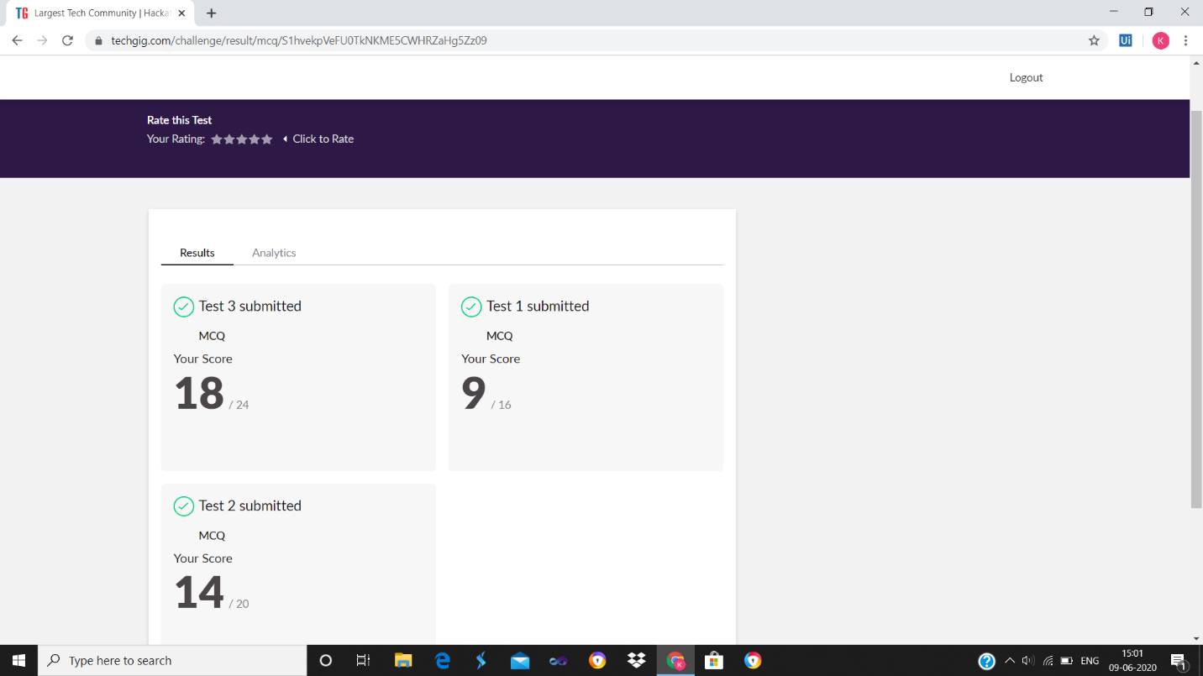

ONLINE PROGRAMING

P-1

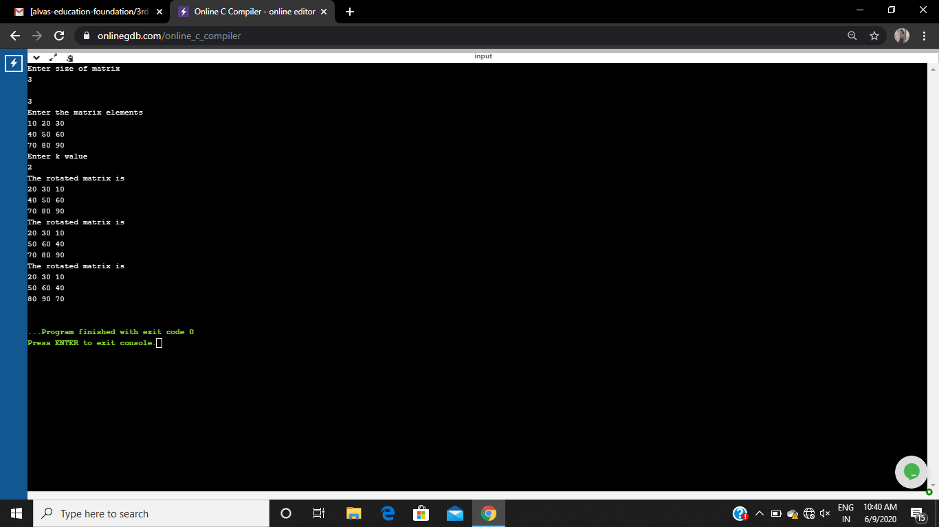

P-2

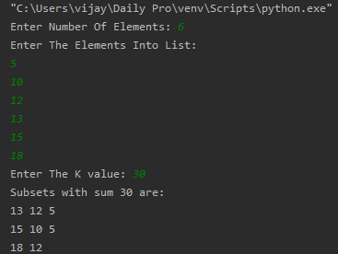

P-3

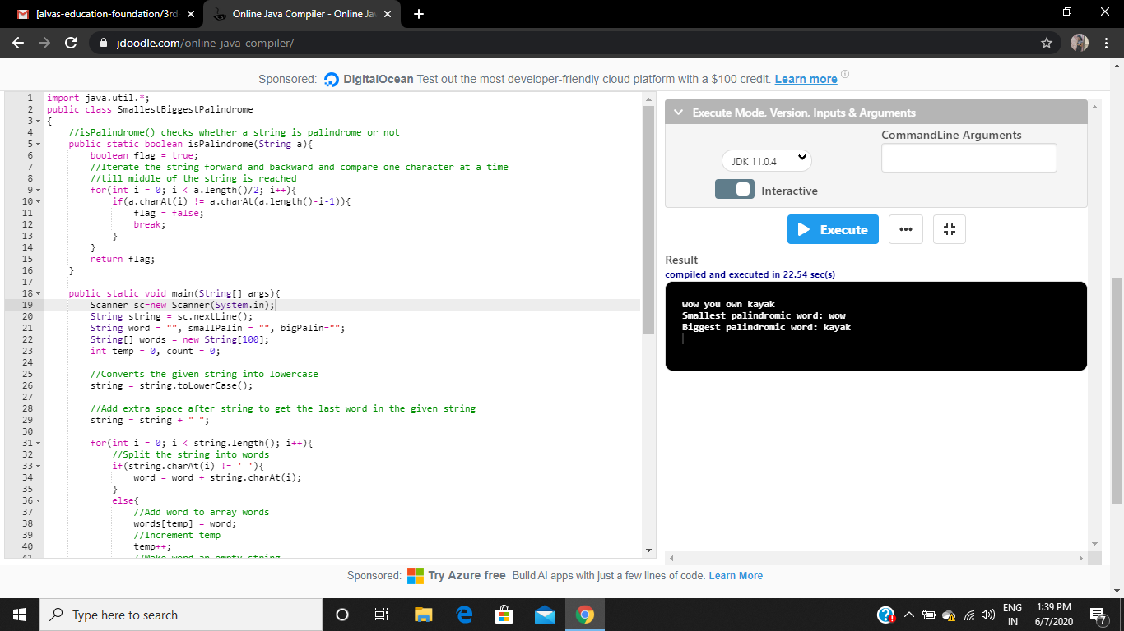

P-4

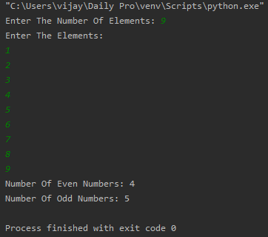

P-5

